DESIGN AND IMPLEMENTATION OF AN AUTOMATED ONLINE STUDENT CLEARANCE SYSTEM USING TWO-FACTOR VERIFICATION PROTOCOL
BY
NNADI SAMSON ONYEBUCHI
REG. NO: 2022/241217
NNADOZIE CHUKWUEBUKA DIVINE
REG. NO: 2022/246736
NNACHETA OKECHUKWU JOSEPH
REG. NO: 2022/249946
A PROJECT REPORT SUBMITTED TO THE DEPARTMENT OF COMPUTER SCIENCE,
FACULTY OF PHYSICAL SCIENCES, UNIVERSITY OF NIGERIA, NSUKKA
IN PARTIAL FULFILMENT OF THE REQUIREMENTS FOR THE AWARD OF THE DEGREE OF BACHELOR OF SCIENCE (B.Sc.) IN COMPUTER SCIENCE
SUPERVISOR: DR. C. I. UGWU
MAY, 2026
CHAPTER ONE
INTRODUCTION
1.1 Background to the Study
Before a student can be said to have truly completed a programme of study in a Nigerian university, there is one more hurdle that stands between the student and the coveted certificate, and that is clearance. Clearance is the process by which a university formally confirms that a graduating or departing student has met every academic, financial, and administrative obligation owed to the institution. It is, in effect, the university's way of closing the file on a student, and it typically cuts across several offices at once, the student's department, the faculty finance office, the library, the alumni office, the Students' Affairs Department, the University Health Centre, the security department, and the audit unit, each of which must independently confirm that the student has nothing outstanding before graduation documents can be released.
For decades, this process has been carried out almost entirely by hand. A student preparing to graduate would typically be issued a clearance form, sometimes a single sheet, sometimes a small booklet, and would then be expected to move physically from office to office, waiting in queues, tracking down the right member of staff, and collecting a signature or a stamp at every stop. Anyone who has gone through this in a Nigerian tertiary institution can attest that it rarely goes as smoothly as it sounds on paper. Offices are not always staffed when a student arrives, signatories travel or fall sick, documents get misplaced in the shuffle of paperwork that passes through a faculty finance office or a library desk in a single week, and errors creep into records that are still being kept largely by hand. The result, more often than not, is a process that drags on for far longer than it reasonably should, sometimes weeks, occasionally longer, leaving students frustrated at the very point where they expect to be celebrating the end of their studies. Usman, Olusanya and Adedeji (2016), writing about the manual clearance process at Tai Solarin University of Education, made much the same observation, describing the process as tedious and unreliable, and noting that even where institutions had attempted to computerise parts of it, the resulting systems were often bare-bones, lacking features as basic as SMS notifications or an interface a student could navigate without help.
It would be a mistake, though, to think that only students bear the cost of an inefficient clearance process. Clearance officers are on the receiving end of a steady stream of forms, documents, and enquiries, particularly in the weeks leading up to convocation, and manually sorting through this volume of paperwork slows their work down considerably and leaves plenty of room for a document to be lost, misfiled, or simply overlooked. Further up the chain, university management is often working with an incomplete picture of what is actually happening on the ground. Without a central point from which to view clearance activity across departments, it becomes genuinely difficult to say with any confidence how many students have finished, how many are still stuck somewhere in the pipeline, or which office is responsible for the bulk of the delay.
It is largely in response to problems of this kind that a number of Nigerian institutions have, over the past decade or so, begun moving their clearance processes online. The general idea is simple enough: replace the paper form and the physical movement between offices with a web-based platform where students can submit the required information digitally and clearance officers can review, approve, or reject that information without needing the student to be physically present. Umezinwa, Uwakwe and Abode (2015) took exactly this approach at Imo State University, developing an online clearance system with the specific aim of doing away with the manual process the institution had relied on until then.
Even so, moving clearance online has not turned out to be a complete solution on its own, and several of the older problems tend to resurface in a new form. A student using an online system will still, quite often, have no clear sense of what stage their clearance has actually reached at any given moment. When a submission is turned down, the reason is frequently left unstated, or stated so briefly that the student is left guessing, which means the same mistake is sometimes repeated on resubmission simply because nobody explained what went wrong the first time.
Communication, more broadly, tends to be one of the weakest links in systems of this kind. Students are not always told, promptly or at all, when something changes with their clearance status, and the tools available to administrators for monitoring activity or pulling together a usable report are frequently limited or absent altogether. Security is a related concern. Where a system relies on nothing more than a username and password to verify who is logging in, student accounts and the data attached to them are left more exposed than they probably should be. Onungwe and Nwachukwu (2017) took this concern seriously enough to propose a secure online clearance system built around fingerprint authentication, reasoning, quite fairly, that a conventional login screen on its own does not offer the level of protection that student records deserve.
Taken together, these recurring gaps, poor visibility into clearance progress, weak communication around rejections, thin or non-existent notification systems, limited reporting for administrators, and authentication that leaves something to be desired, point fairly clearly to the need for a system that does more than simply move the old paper process onto a website. What is needed is a system built from the outset around real-time clearance tracking, timely notifications, clear feedback whenever a submission is rejected, dashboards that give administrators something useful to work with, and a verification protocol strong enough to be trusted with something as consequential as a student's graduation record. In the system proposed in this study, two-factor verification is used not only to confirm the identity of the person logging in, but also to govern movement between the different stages of the clearance process itself. Once a student's submission at a given stage has been reviewed and approved by the officer responsible, the system generates an authentication code tied specifically to that stage. The student is then required to enter and verify that code correctly before the system will allow them to proceed to the next stage. In practical terms, this closes off a gap that many existing systems leave open, namely the possibility of a student advancing through the clearance workflow without each stage having been properly and verifiably completed.
With this arrangement in place, students would, at minimum, always know where their clearance stands and what, if anything, is still expected of them. Clearance officers would be able to review, approve, or reject submissions and, where necessary, explain their decisions, all from within a single system rather than juggling paper files and email threads. The stage-based verification mechanism, for its part, ensures that no student can slip from one clearance level to the next without that transition being properly authenticated. Administrators, meanwhile, would have the reporting tools needed to keep an eye on activity across the board and make decisions based on something more solid than guesswork. The cumulative effect, at least as far as this study is concerned, should be a clearance process that is more transparent, better communicated, more secure, and considerably more efficient than what currently exists.
This study adopts the University of Nigeria, Nsukka (UNN) as the institutional context within which the Automated Online Student Clearance System Using Two-Factor Verification Protocol is designed and implemented. UNN was selected for two main reasons: first, it is the institution to which the researchers are affiliated, which made it possible to observe the clearance process directly and to consult students and staff familiar with its practical operation; second, UNN is a large, multi-faculty federal university whose clearance process cuts across several departments, faculties, and administrative units in a manner broadly representative of what obtains in most Nigerian tertiary institutions. Established on 7th October 1960 as the first indigenous university in Nigeria, UNN operates from its Nsukka and Enugu campuses and is organised into a number of faculties, including the Faculty of Physical Sciences, under which the Department of Computer Science, the department to which the researchers belong, is domiciled, alongside faculties such as Arts, Agriculture, Biological Sciences, Engineering, Law, Education, Social Sciences, and Medical Sciences, serving a student population running into several tens of thousands.
At UNN, as with most Nigerian universities, a graduating or departing student must obtain confirmation from a number of offices, including the student's department, the faculty finance office, the university library, the Alumni office, the Students' Affairs Department, the University Health Centre, the security department, and the audit unit, with the faculty and departmental dues receipts also required to be complete, before the Statement of Results and Original Degree Certificate can be released. Some of these stages already have a degree of online submission built into the existing arrangement, but much of the actual verification, communication, and sign-off still depends on manual effort, physical visits, and paper-based confirmation, consistent with the general weaknesses of the existing process already described above. It is this clearance structure at UNN, its offices, its stages, and its recurring bottlenecks, that the system proposed in this study is modelled on and designed to improve.
1.2 Statement of the Problem
In an ideal setting, a student going through clearance ought to be able to rely on an online system that keeps them properly informed throughout, telling them clearly which stage their clearance has reached, whether that stage has been approved or rejected, and what, if anything, they still need to do. Clearance officers, for their part, ought to be able to manage the requests coming to them in an orderly fashion, and university management ought to have access to data accurate enough to support real monitoring and decision-making.
What actually happens in practice tends to fall short of this on several fronts. To begin with, students working within the current online process frequently cannot tell exactly which stage their clearance has reached, or which department currently has their file, and this leaves them uncertain about what to do next, or indeed whether they need to do anything at all.
Communication between students and clearance officers is another area where the process tends to break down. A document that gets rejected rarely comes back with an explanation clear enough to be useful, so it is not unusual for a student to resubmit the same document with the same error still intact, simply because nobody spelled out what was wrong with it the first time. This adds an avoidable delay to a process that is already slower than it needs to be.
The absence of a proper notification system makes this worse. Students are not consistently informed, and certainly not promptly, when a document has been approved, rejected, or sent back for correction, and reminders or deadlines that matter can be missed outright simply because nothing was sent to flag them.
A further problem, and arguably one of the more serious ones, is that the current process lacks any controlled, authenticated way of moving a student from one clearance stage to the next. An officer approving a student at one stage does not, by itself, provide any real assurance that the student is actually entitled to move on to the following stage. Without some additional verification step built into that transition, there is a genuine risk of a student advancing through the process prematurely, or in a manner that was never properly authorised.
University management, for its part, is left with limited visibility into how clearance is actually progressing across the institution. In the absence of dependable reporting and monitoring tools, it is difficult to say with any precision how many students have completed clearance, how many requests remain outstanding, how many have been turned down, or which offices are responsible for the bulk of the delay at any given time.
Security remains a further sore point. Ordinary login credentials, on their own, offer only limited protection, and a stronger form of verification is needed both to safeguard student accounts properly and to ensure that movement through the different clearance stages is authenticated rather than simply assumed.
If left as they are, these problems translate into continued delay and confusion for students, added strain on clearance officers already handling a heavy volume of requests, and a persistent lack of the information university management needs to oversee the process with any real confidence.
It is against this background that the present study proposes the design and implementation of an Automated Online Student Clearance System Using Two-Factor Verification Protocol, a system built specifically to address these problems through automated processing at each clearance stage, real-time clearance tracking, notifications, rejection feedback, administrative reporting, and stage-based OTP verification. Under this verification protocol, a student is required to successfully authenticate with a stage-specific code after completing a given clearance stage before access to the next stage is granted, an arrangement intended to improve transparency, communication, monitoring, security, and control across the entire clearance process.
1.3 Aim and Objectives of the Study
This study aims to design and implement an Automated Online Student Clearance System Using Two-Factor Verification Protocol that improves transparency, communication, monitoring, security, and controlled progression in the student clearance process. In pursuit of this aim, the study sets out to:
1. Design and implement a real-time clearance tracking feature that allows students to monitor the progress of their clearance at different stages.
2. Develop an administrative dashboard for monitoring clearance activities and generating reports on completed, pending, rejected, and delayed clearance requests.
3. Implement an email notification feature that informs students about important clearance updates, including approvals, rejections, and required corrections.
4. Develop a rejection feedback mechanism that allows clearance officers to provide clear reasons for rejected documents or clearance requests.
5. Implement a Two-Factor Verification Protocol using stage-specific One-Time Password (OTP) verification to improve security and authenticate a student's eligibility to proceed from one clearance stage to the next.
1.4 Scope of the Study
This study is concerned with the design and implementation of an Automated Online Student Clearance System Using Two-Factor Verification Protocol, built with the specific intention of improving the clearance process through the use of web-based technology rather than simply digitising the existing paper-based workflow.
For students, the system provides account access, a means of submitting documents and information, the ability to track clearance progress in real time, notifications as their status changes, visibility into any feedback attached to a rejected submission, and an authenticated pathway through the different clearance stages, one that they cannot bypass by accident or otherwise.
For clearance officers, the system supports reviewing submissions, approving or rejecting documents, issuing rejection feedback where a submission falls short, updating clearance status as work progresses, and generating the authentication code a student needs to proceed to the next stage once clearance at the current stage has been successfully completed. Administrators, for their part, are able to manage user accounts, monitor clearance activity across departments, and generate reports covering the process as a whole.
At the core of the system are automated processing at each clearance stage, real-time clearance tracking, an email notification feature, administrative dashboards, report generation, a rejection feedback mechanism, and a Two-Factor Verification Protocol built around stage-specific OTP authentication. The verification mechanism is designed so that successful completion of a clearance stage is always followed by an authentication step before the student is permitted to move on to the next stage. On the technical side, the system is built using HTML, CSS, and JavaScript on the front end, Python with the Flask framework on the back end, and MongoDB for data storage.
This study is confined specifically to the student clearance process. It does not extend to other university functions such as admission processing, course registration, result computation, hostel allocation, or NYSC registration and verification, and it is not intended to replace external systems such as national payment platforms or government verification systems, both of which fall outside the boundaries of what this project sets out to do.
1.5 Significance of the Study
This study stands to benefit several distinct groups: students, clearance officers, university management, the university as an institution, and future researchers and software developers.
For students, the most immediate benefit is that clearance becomes something they can actually follow and manage, rather than a process that happens to them somewhere out of sight. They can track their progress without needing to make repeated visits to different offices, and they receive notifications the moment a document is approved, rejected, or sent back for correction. The rejection feedback feature is particularly useful here, since it helps a student understand exactly what went wrong with a submission and what needs to change before resubmitting it. The two-factor verification mechanism, on top of this, gives students a controlled and transparent means of moving from one clearance stage to the next, so that progress, once made, is not left in any doubt.
For clearance officers, the system offers a considerably more organised way of handling the requests that come their way. Reviewing documents, approving or rejecting them, providing feedback, updating statuses, and controlling a student's progression to the next clearance stage all take place within a single system, rather than being spread across paper files, spreadsheets, and email correspondence. This cuts down on manual work and, just as importantly, improves the quality of communication between officers and the students they are dealing with.
For university management, the administrative dashboard and reporting tools offer a level of visibility into clearance activity that the current process simply does not provide, indicating how many clearances are complete, how many are still pending, how many have been rejected, and where the delays are concentrated. That kind of information supports better decision-making and makes it far easier to identify exactly where improvement is needed, rather than relying on impressions or anecdotal reports from individual offices.
For the university as a whole, the system contributes to more efficient and more transparent administrative service delivery, by cutting down on unnecessary delay, improving communication between students and staff, and introducing a more controlled and more secure process for progression through the different clearance stages. Finally, for future researchers and software developers, this study serves as a reliable reference point for further work on student management systems, automated clearance systems, information security, two-factor verification, and administrative automation.
1.6 Limitation of the Study
This study is limited to the core features set out in its objectives, namely automated processing at each clearance stage, real-time clearance tracking, email notification, rejection feedback, administrative reporting, and a Two-Factor Verification Protocol using stage-specific OTP authentication.
A significant limitation of this study, and one worth stating plainly, is that the student clearance process as a whole cannot be fully automated. Certain aspects of clearance in a Nigerian university setting, by their nature, still require manual handling and cannot simply be moved online within the scope of a project of this kind. Payment is one clear example: at UNN, as in most Nigerian universities, payments such as school fees, faculty dues, the homecoming fee, library fees, the fee paid for the Alumni handbook and I.D card, the fee paid at the security department, and the convocation fee are processed manually or through separate, already-established university payment channels tied to the faculty finance office, the Remita payment platform, and the individual offices concerned, over which the researchers have no direct control. Integrating the proposed system with these live payment and processing channels, so as to reconcile transactions in real time, was outside what this project could realistically undertake. Consequently, payment and processing confirmation for these categories of clearance is treated as an input the system relies on rather than a transaction the system itself carries out. In the same vein, certain signatory approvals within the clearance workflow have no provision for a digital signature within the system; where this applies, the relevant signatory still signs the document physically, after which the signed document is scanned and uploaded into the system so that the clearance process can continue online from that point. Similarly, certain categories of documents are considered too sensitive to be cleared purely on the strength of an electronic upload. Original receipts and tellers, signed and stamped clearance forms, the Alumni ID card, and similarly sensitive documents typically still require a level of physical verification, authentication, or manual sign-off by the relevant office, owing to concerns around forgery, authenticity, and the administrative weight such documents carry. For this reason, the proposed system automates the tracking, notification, feedback, and stage-progression aspects of clearance, while accepting that a residual manual component, particularly around payment reconciliation and sensitive document verification, will remain necessary regardless of the level of automation introduced.
The system was also built and tested as a prototype, using sample data rather than live institutional records, since access to actual student clearance data was not available to the researchers, owing to privacy and administrative restrictions that made it impractical to work with real records within the scope of this project. It was not integrated with UNN's existing student information systems or payment platforms, and its performance under full production conditions, including the internet connectivity and infrastructural constraints commonly experienced within Nigerian tertiary institutions, has therefore not been fully established.
The work was also carried out within the time constraints of a single academic session, which naturally limited how extensively the system could be tested and how many additional features could realistically be incorporated without compromising the quality of what was already planned. Finally, and in line with the scope stated earlier, the system does not extend to other university processes such as admission, course registration, or hostel allocation, nor does it cover NYSC registration, all of which lie outside what this study set out to address.
1.7 Definition of Terms
Student Clearance: The process through which a student obtains approval from relevant university departments after fulfilling the required academic, financial, and administrative obligations before graduation.
Online Student Clearance System: A web-based system that allows students and university staff to carry out clearance activities electronically.
Automated Online Student Clearance System: A web-based clearance system that automates the processing, monitoring, and progression of students through the different stages of the clearance process.
Real-Time Clearance Tracking: A feature that allows students to monitor the current progress and status of their clearance at different stages.
Clearance Stage: A specific level or departmental step within the student clearance process that must be successfully completed before the student can proceed to the next stage.
Two-Factor Verification Protocol: A security mechanism that uses an additional verification step to authenticate a user's eligibility or action beyond the initial authentication process.
One-Time Password (OTP): A temporary authentication code that is used once to verify a user's identity or authorize progression to a subsequent clearance stage.
Stage-Based OTP Verification: A verification mechanism in time in which a student must successfully enter an OTP associated with a completed clearance stage before being permitted to proceed to the next stage.
Notification System: A system that sends information or alerts to users about important activities or updates.
Email Notification: An electronic message sent to a user's email address to provide information about clearance activities.
Rejection Feedback Mechanism: A feature that allows a clearance officer to explain the reason why a document or clearance request was rejected.
Administrative Dashboard: A control panel that allows administrators or authorized officers to view information, monitor activities, and manage system operations.
Report Generation System: A system feature that produces organized information about clearance activities for monitoring and decision-making.
Authentication: The process of confirming the identity or eligibility of a user before allowing the user to access or perform a particular operation in a system.
Authorization: The process of determining what a user is allowed to access or do after authentication.
Database Management System: Software used to store, organize, manage, and retrieve data.
Web-Based Information System: A computer system that can be accessed and used through a web browser.
Information Security: The protection of information and systems from unauthorized access, loss, alteration, or misuse.

CHAPTER TWO
LITERATURE REVIEW
2.0 Introduction
This chapter presents the review of related literature relevant to the design and implementation of an Automated Online Student Clearance System Using Two-Factor Verification Protocol. It begins with the theoretical background of the study, covering the concepts and technologies that underpin the proposed system, before examining related studies on online student clearance systems and comparable information systems. The chapter considers the different approaches adopted by previous researchers in addressing the challenges associated with manual and partially automated clearance processes. Particular attention is given to clearance tracking, communication, administrative monitoring, document processing, authentication, authorization, notification systems, and One-Time Password (OTP) verification. The chapter concludes by identifying the research and technological gaps in the existing literature which the present study seeks to address.
2.1 Theoretical Background
Before examining related work, it is useful to establish the concepts and technologies that shape the proposed system. Student clearance involves several activities and participants, making it necessary to understand the concepts that support its automation. This section discusses the meaning and operation of student clearance systems, clearance tracking, communication, monitoring, document validation, authentication, authorization, two-factor verification, OTP verification, database management, web-based information systems, and information security. It also examines the technologies adopted in developing the proposed system and explains the role each technology plays in the overall system architecture.
2.1.1 Concepts
Student clearance refers to the process by which a student obtains approval from the relevant departments and units of a university before completing their studies or receiving graduation documents, confirmation, in effect, that the student has met all required academic, financial, and administrative obligations. Depending on the institution, this can involve the student's department, faculty finance office, library, alumni office, Students' Affairs Department, health centre, security department, and audit unit, each responsible for verifying a particular obligation before granting approval. In a traditional manual process, a student may be required to move from one office to another to obtain the necessary approvals. This approach can result in long queues, delays, missing documents, repeated visits, and limited visibility into the actual progress of the clearance. An online student clearance system is therefore intended to reduce these difficulties by providing a centralized platform through which clearance activities can be performed and monitored electronically.
An online student clearance system is a web-based information system designed to support the electronic processing and management of student clearance activities. Instead of depending entirely on physical forms and face-to-face interaction, the system provides an environment in which students can submit required information and documents while authorized officers review, approve, reject, and update clearance requests electronically. The use of an online platform can improve accessibility because students and authorized staff can interact with the system without necessarily being physically present in the same location.
A major concept associated with the proposed system is real-time clearance tracking. Real-time clearance tracking allows students to monitor the current status of their clearance and identify the stage at which their requests are being processed. Rather than depending on verbal enquiries or physical visits to clearance offices, students can obtain information about their progress directly from the system. This provides greater transparency and reduces uncertainty about whether a particular clearance requirement has been completed, is pending, or requires further action.
The concept of clearance stages is particularly important to the present study. Student clearance normally involves a sequence of approvals from different departments or units. Each stage represents a specific part of the overall clearance process and may require the student to submit documents or satisfy particular requirements before approval can be granted. In the proposed system, progression between stages is not treated simply as an automatic movement from one department to another. Instead, the completion of a stage is followed by an additional verification process. Once the responsible officer approves a student's clearance at a particular stage, a stage-specific One-Time Password is issued to the student. The student must successfully enter and verify the OTP before the system permits progression to the next stage. This creates an additional layer of control over the movement of students through the clearance workflow.
Communication is another important concept in an online clearance system. A notification system, at its simplest, is a mechanism for alerting users when something relevant happens. Within the context of student clearance, notifications can inform students when their clearance status changes, when a document is approved or rejected, when a correction is required, or when an important action is expected from them. Effective notification reduces the need for students to repeatedly check with clearance officers or physically visit offices for updates.
Email notification is one practical means of providing this communication. By sending clearance-related updates to a student's registered email address, the system can provide a written record of important events. Students can therefore remain informed about their clearance activities even when they are not actively logged into the system. Email notifications can be particularly useful when a document has been approved, rejected, or returned for correction.
Closely related to notification is the rejection feedback mechanism. A clearance request may be rejected when submitted information or documentation does not satisfy the requirements of a particular clearance stage. Without a clear explanation, a student may not understand the reason for the rejection and may submit the same incorrect information again. A rejection feedback mechanism allows the responsible clearance officer to provide a specific explanation of the problem. This makes the rejection actionable because the student can understand the required correction before making another submission.
On the administrative side, an administrative dashboard functions as a central point from which authorized staff can view and manage clearance activities. It can provide information about completed, pending, rejected, or delayed clearance requests. Such a dashboard reduces the difficulty of obtaining information from separate records and enables authorized personnel to monitor activities from a centralized interface. It can also help administrators identify patterns and bottlenecks in the clearance process.
A report generation system builds on the information maintained by the administrative dashboard by converting stored records into organized reports. Such reports can provide information about the number of completed clearance requests, pending requests, rejected submissions, or other relevant activities. The availability of organized reports can support administrative monitoring and decision-making by providing a clearer picture of the performance of the clearance process.
Document validation is another practical component of the proposed system. Students may be required to upload different documents during the clearance process. Document validation involves checking whether submitted files satisfy the basic requirements established by the system, such as acceptable file type or file size. This helps maintain consistency in the documents stored within the system and reduces unnecessary processing of files that do not meet the required conditions.
A complaint and support feature provides students with a formal channel through which they can report difficulties encountered while using the system. Such difficulties may include problems with document submission, unclear instructions, rejected submissions, or other system-related issues. Providing a structured support mechanism can improve communication between students and authorized personnel and can help ensure that problems encountered during the clearance process are properly recorded and addressed.
Security is a fundamental concern in systems that store personal, academic, and administrative information. Authentication is the process of confirming that a user is who they claim to be. In a student clearance system, authentication may involve the use of registration information and a password to establish the identity of a user before access is provided.
Authorization operates after authentication and determines what an authenticated user is permitted to access or perform. Different categories of users may have different privileges. For example, a student may be authorized to view personal clearance information and submit documents, while a clearance officer may be authorized to review and approve or reject submissions. An administrator may have broader privileges for managing users, monitoring clearance activities, and generating reports. Separating authentication from authorization helps ensure that users can only perform actions appropriate to their roles.
The present study introduces an additional security and workflow-control mechanism through a Two-Factor Verification Protocol. Two-factor verification involves the use of an additional verification factor beyond the primary authentication process. In this study, the additional verification is implemented through a stage-specific One-Time Password. The purpose is not merely to provide another login mechanism but to authenticate the student's eligibility to proceed from one clearance stage to another.
A One-Time Password (OTP) is a temporary authentication code that is designed for a single verification purpose and is not intended for repeated use. Within the proposed system, an OTP is generated after a student's clearance at a particular stage has been approved by the responsible officer. The code is then provided to the student through the configured verification channel. The student must enter the correct code before the system authorizes movement to the next stage. Consequently, successful completion of a clearance stage does not automatically provide unrestricted access to the next stage; the required verification must first be completed.
This approach provides a relationship between authentication and clearance progression. The OTP therefore serves as both a verification mechanism and a workflow-control mechanism. If the student enters an incorrect or invalid code, progression to the subsequent stage is not authorized. This helps ensure that each stage is completed and verified before the student proceeds further in the clearance process.
Underlying all of these concepts is the manner in which the system stores and manages information. A Database Management System (DBMS) provides the organized structure required to store, retrieve, update, and manage information reliably. In this project, MongoDB is used for storing records associated with students, system users, clearance activities, notifications, and other relevant information.
Because the proposed system is web-based, it can be accessed through a web browser without requiring a separate application to be installed on every user's device. This provides a practical means for students, clearance officers, and administrators to interact with the system. The web-based nature of the system also supports centralized management of information and clearance activities.
Information security therefore runs throughout the design of the system. Student records may contain personal information, registration numbers, email addresses, uploaded documents, and clearance records that should not be accessible to unauthorized persons. Security measures such as authentication, authorization, password protection, OTP verification, and controlled access to system functions work together to protect these records and ensure that only authorized activities can be performed.
2.1.2 Technology
The proposed system draws on a combination of web technologies, programming technologies, database technology, and communication mechanisms. Each technology performs a distinct role in the development and operation of the system.
On the front end, HyperText Markup Language (HTML) is used to structure the user interface. HTML provides the basic structure for pages, forms, headings, buttons, tables, navigation elements, and other components through which students, clearance officers, and administrators interact with the system. It therefore provides the foundation upon which the visual and interactive aspects of the application are built.
Cascading Style Sheets (CSS) is used to control the presentation and appearance of the system. It determines aspects such as fonts, spacing, positioning, sizing, colors, and layout. Through CSS, the system interface can be organized in a consistent manner across its different pages. A clear and consistent interface is particularly important in a system that is expected to be used by different categories of users performing different activities.
JavaScript provides the interactive functionality of the front end. While HTML establishes the structure of a page and CSS controls its presentation, JavaScript enables the interface to respond to user actions. It can be used for activities such as client-side form validation, interactive elements, dynamic content, and other behaviours that improve the responsiveness of the application. JavaScript therefore contributes to the usability of the student, officer, and administrator interfaces.
On the back end, the system is developed using Python. Python is used to implement the server-side logic responsible for processing requests, managing application operations, handling user-related activities, and communicating with the database. Its relatively clear syntax and broad ecosystem make it suitable for developing web-based applications.
The Flask framework is used with Python to support the back-end development of the system. Flask is a lightweight web framework that provides mechanisms for handling routes, requests, responses, and other server-side operations. In the proposed system, Flask serves as the connection between the front-end interface and the underlying application logic and database. It can therefore handle activities such as authentication, clearance processing, verification, and communication with stored records.
The database used in the proposed system is MongoDB. MongoDB is a document-oriented database management system in which information is stored in flexible documents organized into collections. Unlike traditional relational database systems that primarily organize information into rows and tables, MongoDB uses a document-based structure. This provides flexibility in handling different categories of information required by the system, including student records, user information, clearance progress, notifications, and other application data.
The choice of MongoDB also supports the management of records whose structures may differ according to the type of information being stored. For example, information associated with a student account may differ from information associated with a clearance request or notification. The document-oriented structure therefore provides a flexible approach to storing the different data entities required by the application.
Another technology supporting the proposed system is email notification technology. This technology is responsible for sending important clearance-related information to students through their registered email addresses. When a relevant event occurs, such as an approval, rejection, or request for correction, the system can generate and send an appropriate notification. This helps maintain communication between the system and its users.
OTP verification technology supports the additional verification mechanism introduced in the proposed system. The system generates a temporary verification code associated with the relevant clearance stage. After an officer has approved the student's clearance at that stage, the student receives the required OTP and enters it into the system. The system then validates the submitted code before allowing the student to proceed to the next clearance stage. This approach provides a controlled transition between stages rather than allowing unrestricted progression.
The combination of these technologies provides the foundation for the proposed system. HTML, CSS, and JavaScript support the user-facing interface; Python and Flask handle server-side processing and application logic; MongoDB provides data storage and management; email technology supports communication; and OTP verification provides an additional authentication and workflow-control mechanism.
2.2 Review of Related Literature
Adamu (2022) conducted a study on an online clearance system, focusing on the problems associated with the traditional clearance process, where graduating students physically visit different offices to obtain approval. The researcher developed an online clearance system to improve the process and reduce the stress associated with moving between offices, and found that it improved convenience, accessibility, and efficiency. Contribution: Demonstrated the viability of migrating clearance online. Similarities: Both utilize web-based architecture to eliminate physical movement. Differences: Adamu's work centered mainly on basic digital submission, whereas the present study incorporates real-time clearance tracking, administrative monitoring, email notifications, rejection feedback, and a Two-Factor Verification Protocol based on stage-specific OTP verification.
Awofolaju, Bada, Alawode, and Orotosho (2023) designed and implemented an automated departmental clearance system aimed at improving the manual clearance process in universities, using web technologies to reduce processing time, paperwork, document loss, and the need for physical presence. Contribution: Streamlined departmental workflow automation. Similarities: Both use web technologies to automate clearance and reduce manual delays. Differences: The present study differs in its choice of MongoDB for flexible document storage, and in its emphasis on real-time clearance tracking, email notifications, rejection feedback, administrative reporting, and stage-specific OTP verification.
Essel, Techie-Menson, Oppong, and Alakuu (2023) examined the digitalization of clearance processes in higher education institutions through the design of an online clearance system that reduced reliance on manual, paper-based procedures and provided role-based access for different categories of users. Contribution: Established role-based access paradigms for academic clearance. Similarities: Shared goal of improving clearance through digital technology and role-based access. Differences: The present study utilizes a Python, Flask, and MongoDB technology stack and uniquely integrates real-time tracking, email notifications, rejection feedback, administrative reports, and stage-specific OTP verification.
Ekoro and Bassey (2024) developed a web-based clearance system for students in Nigerian Colleges of Education, addressing problems such as physical movement between offices, paper-based records, missing documents, and the unavailability of officers required to sign off on clearance forms. Contribution: Addressed multi-office bottlenecks in tertiary institutions. Similarities: Shared aim of reducing stress and record-management problems through a web-based platform. Differences: The present study extends beyond basic automation by incorporating real-time clearance tracking, email notifications, rejection feedback, administrative monitoring, report generation, and a Two-Factor Verification Protocol.
Adegoke and Olalekan (2026) designed a workflow-driven online student clearance system for multi-departmental integration, automating clearance activities across departments through role-based access control, department-specific document submission, email notifications, QR-code clearance certificate verification, and real-time clearance tracking. Contribution: Advanced multi-departmental workflow integration. Similarities: Both focus on multi-departmental clearance and include real-time tracking and email communication. Differences: The present study differs in its use of Flask and MongoDB and in its particular emphasis on stage-specific OTP verification, rejection feedback, and administrative report generation.
2.3 Research / Literature Gap
The literature reviewed shows that researchers have approached the problems associated with manual clearance from different perspectives and have achieved improvements in areas such as reducing physical movement, paperwork, processing delays, and difficulties associated with manual record management. However, significant gaps remain across the systems reviewed.
Several of the reviewed systems focus primarily on digitizing the clearance process without providing students with a sufficiently clear and real-time view of their progress through the different clearance stages. Others provide mechanisms for online submission and approval but do not place strong emphasis on providing detailed rejection feedback that explains why a particular submission was rejected and what the student needs to correct.
A related gap concerns communication and administrative monitoring. Although some systems incorporate notification features, the combination of timely email communication, administrative monitoring, report generation, and detailed rejection feedback is not consistently provided within the same system. This creates an opportunity for an integrated system that allows students to remain informed while giving administrators a centralized means of monitoring clearance activities and generating useful reports.
Security and controlled progression also represent an important area of difference. Role-based access and conventional authentication are present in many information systems, but the use of an additional verification mechanism specifically to authorize progression from one clearance stage to another is less emphasized in the reviewed systems. A student being authenticated into the system does not necessarily establish that the student has completed and been authorized to move beyond a particular clearance stage. The present study therefore introduces a stage-based Two-Factor Verification Protocol in which a One-Time Password is issued after the successful completion and approval of a clearance stage. The student must successfully verify the OTP before the system permits access to the subsequent stage.
There is also a technological gap in the specific combination of technologies applied to online student clearance systems. The reviewed systems have employed different programming languages, frameworks, and database technologies. The present study adopts HTML, CSS, and JavaScript for the front end, Python with Flask for the back end, and MongoDB for data storage, providing a robust and flexible technological implementation of the clearance process.
The present study therefore addresses these identified gaps through the design and implementation of an Automated Online Student Clearance System Using Two-Factor Verification Protocol. The system brings together real-time clearance tracking, administrative dashboards and report generation, email notifications, rejection feedback, and stage-specific OTP verification. These features provide students with clearer visibility into their clearance progress, provide useful information when submissions are rejected, improve communication throughout the clearance process, and provide stronger control over progression between clearance stages. At the administrative level, the system provides tools for monitoring clearance activities and generating reports, while its Two-Factor Verification Protocol provides an additional layer of authentication for movement between completed clearance stages.

CHAPTER THREE
SYSTEM ANALYSIS AND DESIGN METHODOLOGY
3.0 Introduction
This chapter acts as the blueprint of the study, detailing how the design and development of the UNN Online Clearance System were conducted. It describes how research was conducted, explains why a specific methodology was chosen, details how data concerning the existing system were collected and analyzed, and provides solutions to the highlighted shortcomings of the manual system. Furthermore, this design phase provides a comprehensive description of the proposed system architecture, input and output specifications, database design, and system modeling using the Object-Oriented Analysis and Design Methodology (OOADM), with Unified Modeling Language (UML) diagrams illustrating the structure and behavior of the system.
3.1 Methodology
The methodology adopted for this project is the Object-Oriented Analysis and Design Methodology (OOADM). OOADM focuses on identifying system objects, their attributes, methods, and relationships, providing a structured, modular, and maintainable approach for analyzing, designing, and implementing software systems. The Unified Modeling Language (UML) is utilized as the modeling standard for representing system components and interactions.
The major stages of OOADM adopted in this project include:
1. Requirement Analysis: Identifying user needs, system actors (Students, Clearance Officers, Administrators, Auditors), and functional/non-functional requirements.
2. System Design: Structuring system architecture, defining classes, objects, attributes, methods, and interaction flows via UML Use Case, Class, Sequence, and Activity diagrams.
3. Database Design: Designing the MongoDB document collections and schemas for users, clearance requests, notifications, progress tracking, and audit logs.
4. Implementation: Developing the front-end interface using HTML, CSS, and JavaScript, and back-end logic using Python Flask and MongoDB.
5. Testing and Deployment: Conducting unit testing, integration testing, user acceptance testing, and deploying the web application.
3.2 System Analysis
3.2.1 Description of the Existing System
The existing student clearance process in many higher institutions is largely manual and paper-based. Students are required to move physically from one department or office to another to obtain signatures, stamps, and approvals from authorized personnel before they can be fully cleared. This process typically involves the collection of clearance booklets, physical submission of documents, manual verification by departmental officers, manual sign-offs, and physical compilation of clearance records.
At the University of Nigeria, Nsukka, the final clearance of a graduating student follows a fixed sequence of physical visits to the offices concerned. The student first goes to the student's department for departmental clearance, confirming that nothing is outstanding with the department. The student then takes the online school fees receipts and the Remita (bank) tellers for each year, the faculty dues receipts from first to final year, and the homecoming receipt to the faculty's finance office for conversion, and the absence of any of these tellers may attract fines. The student then goes to the Library with the library card to be cleared. A student who was never registered with the library must present the school fees receipt and a passport photograph, while a student who holds a first year library card presents it and pays cash only for the other years. Next, the student proceeds to the Alumni office at Berlima, the building beside Marlima, with the final year online school fees receipt, pays N650 in cash, and collects the Alumni handbook and I.D card.
The student then proceeds to the Students' Affairs Department for accommodation clearance. Two offices after the Dean's office is the Clearance Room, where the student respects the queue, if there is one, collects the forms to be filled, and submits them for stamping. Next, the student proceeds to the University Health Centre for health centre clearance, confirming that the student has no outstanding obligation to the centre before proceeding to the security department.
The student then goes to the security department with N1,000 in cash. The student does not enter the office but stands outside at the window to the right and presents the following documents in order: the school I.D card collected at the ICT Centre, the school fees clearance receipt, the accommodation clearance, the library clearance, the Alumni I.D card, and the off-campus clearance, all of which, together with other documents, are pasted on the window of the security department. Two papers are given to the student to fill in personal details, and both are returned to the security department. The student comes back the next day to collect the one that has been signed and stamped. The reason for this arrangement is to allow the security department to confirm that the student has no files with it; where the documents are signed on the same day, the student escapes this scrutiny, although any file found must be closed by payment.
The student also generates an invoice for the convocation fee and pays it at any bank that accepts Remita, keeping the invoice, teller, and receipt intact. This can be done at any point during the clearance process. After the result list is out, the student writes a typed formal letter titled 'Application for the Collection of My Statement of Results and Original Degree Certificate', addressed to the Office of the Deputy Registrar. The papers are then arranged in the following order: the school fee clearance certificate; the letter of application; the security clearance certificate; the accommodation clearance; the convocation fee (N10,000) teller, invoice, and receipt; the library clearance form; and the Alumni I.D card. Two extra photocopies are made and arranged in the same order, giving one original copy and two photocopies.
All three copies are taken to the audit unit at the back of PAA, upstairs, to be signed and stamped. The entrance to the audit office is at the side of the building; the student climbs the staircase and finds the audit office at the end, on the left, with the instructions for clearance time and paper arrangement displayed opposite the door. The student leaves with the original copy and one photocopy, and the audit unit keeps one photocopy. Every clearance document received from the beginning of the process must be presented at the audit unit. Finally, the student ensures that all faculty and departmental dues receipts are complete and intact, and completes any that are missing. A student who cannot carry out the clearance in person must give another person an authorisation letter to act on his or her behalf.
3.2.1.1 Weaknesses of the Existing System
The manual clearance process suffers from numerous severe limitations, including:
- Time-Consuming Procedure: Students spend weeks moving across offices and waiting in long queues.
- Document Misplacement: Physical files and papers are frequently lost, misplaced, or damaged.
- Lack of Real-Time Tracking: Students have no visibility into the exact stage or location of their clearance files.
- Poor Communication: Rejections lack clear feedback, forcing students to guess errors and repeat submissions.
- Inefficient Record Management: Manual record keeping is cumbersome, prone to human error, and difficult to audit.
- Security Vulnerabilities: Physical records lack access control, exposing student records to unauthorized alterations.
- Administrative Bottlenecks: University management lacks centralized visibility to monitor bottlenecks and generate timely reports.
3.2.2 Analysis of the Proposed System
The proposed Enhanced Online Student Clearance Management System is a robust web-based platform designed to automate and improve the student clearance workflow. The proposed system empowers students to register and log in securely, submit clearance requests online, upload required credentials electronically, track clearance progress in real-time, receive instant email notifications, submit support tickets, and receive actionable feedback on rejected applications.
Simultaneously, the system enables clearance officers to review uploaded documents, approve or reject applications with detailed feedback, update clearance statuses, and issue stage-specific OTP verification codes. Administrators are equipped with comprehensive dashboards to monitor system-wide activities, manage user accounts, oversee departmental workflows, generate analytical reports, and maintain system security.
The clearance stages configured in the proposed system follow the same order in which clearance is carried out at UNN. These are the student's department, for departmental clearance; the faculty finance office, where the school fees, faculty dues, and homecoming receipts are converted; the Library; the Alumni office; the Students' Affairs Department for accommodation clearance; the University Health Centre for health centre clearance; and the security department. The convocation fee invoice, teller, and receipt are recorded as a separate requirement that the student may complete at any point. After the result list is out, the student uploads the typed application addressed to the Office of the Deputy Registrar, and the final stage is the audit unit, which signs and stamps the arranged documents. The system also tracks whether the student's faculty and departmental dues receipts are complete. At each stage, the responsible officer approves or rejects the submission and a stage-specific OTP is issued on approval, so that the student cannot move to the next office out of sequence.
Payments made in cash or at the bank, including the Alumni fee, the security department fee, and the convocation fee, are still made through the existing channels. The student uploads the resulting receipts or tellers, and the officer confirms them before approving the stage. Documents that must be physically signed and stamped are scanned and uploaded after signing, in line with the limitation stated in Chapter One.
3.3 System Design
System design translates the requirements analysis into a blueprint for software construction. In accordance with OOADM, the structural and behavioral aspects of the system are modeled using UML diagrams.

3.3.1 Class Diagram
The Class Diagram illustrates the static structure of the system, defining classes such as User, Student, ClearanceOfficer, Admin, ClearanceRequest, Document, Notification, Complaint, OTP, and Report, along with their attributes, methods, and associations.
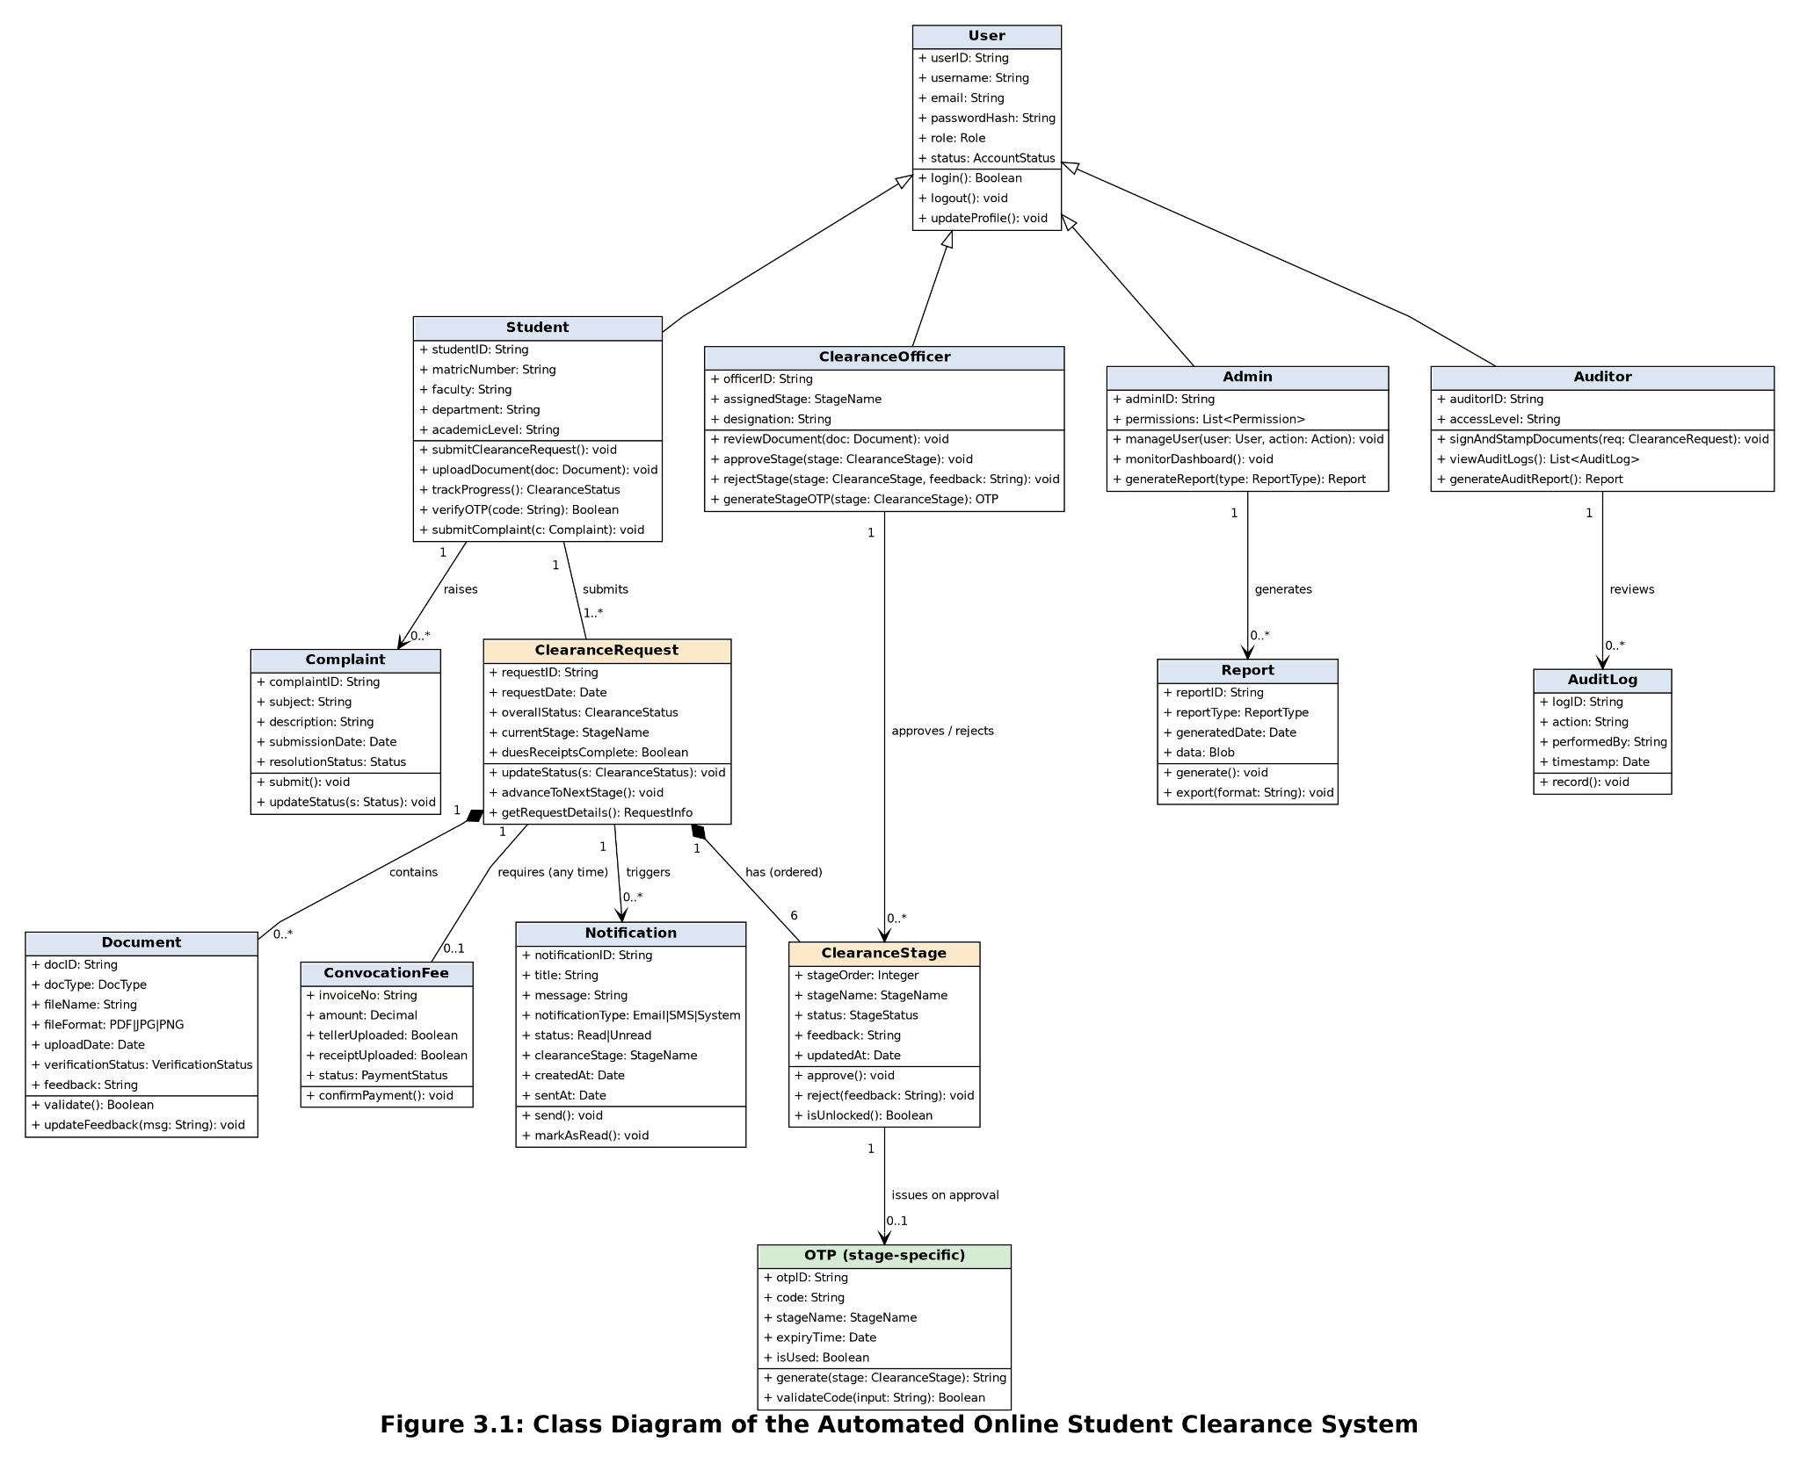

3.3.2 Sequence Diagram
The Sequence Diagram models the dynamic interactions between system objects over time during specific use cases, such as user authentication, OTP verification, document upload, officer review, and administrative report generation.
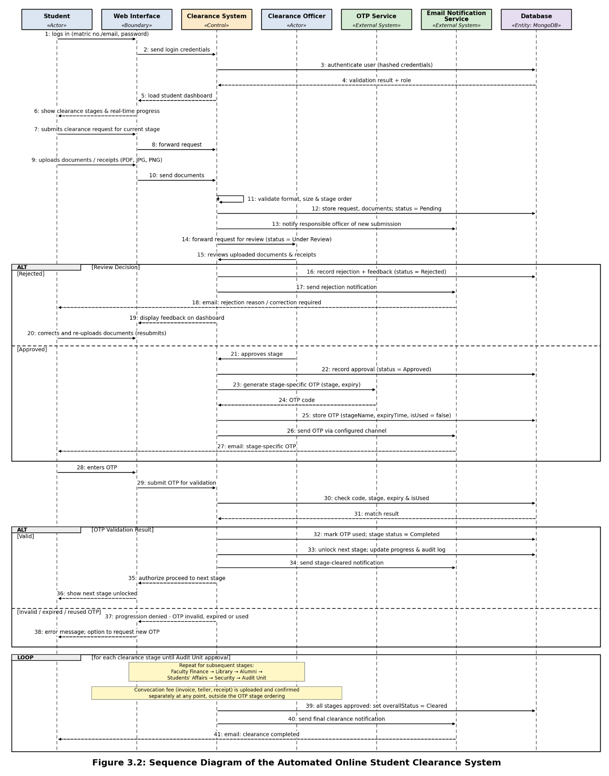

3.3.3 Database Design
The database is implemented using MongoDB, a document-oriented NoSQL database management system. Data is stored in flexible JSON-like documents organized into collections. Below are the primary database collections and schema structures:
Table 3.1: Notifications Collection Schema Structure
Field | Type | Description
_id | ObjectId (PK) | Unique identifier for each notification record.
student_id | ObjectId (FK) | References the student receiving the notification.
title | String | Short title summarizing the notification.
message | String | Detailed notification message content.
notification_type | String | Channel type (Email, SMS, System).
status | String | Read or Unread status indicator.
clearance_stage | String | Associated clearance stage.
created_at | Date | Timestamp when notification was created.
sent_at | Date | Timestamp when notification was transmitted.

Table 3.2: Progress Collection Schema Structure
Field | Type | Description
_id | ObjectId (PK) | Unique identifier for the progress record.
clearance_request_id | ObjectId (FK) | References the student's clearance request.
student_id | ObjectId (FK) | References the student.
department_id | ObjectId (FK) | References the department handling the stage.
stage_name | String | Name of the clearance stage (e.g., Faculty Finance Office, Library).
status | String | Current stage status (Pending, Under Review, Approved, Rejected).
feedback | String | Rejection reason or officer comments.
updated_by | ObjectId (FK) | Clearance officer who updated the status.
updated_at | Date | Timestamp of the status update.

3.3.4 Input and Output Design
Input design specifies the format and validation rules for data entering the system, including user registration credentials, login details, OTP codes, clearance documents (PDF, JPG, PNG), and support complaints. Input validation ensures data integrity through client-side JavaScript checks and server-side Flask sanitization.
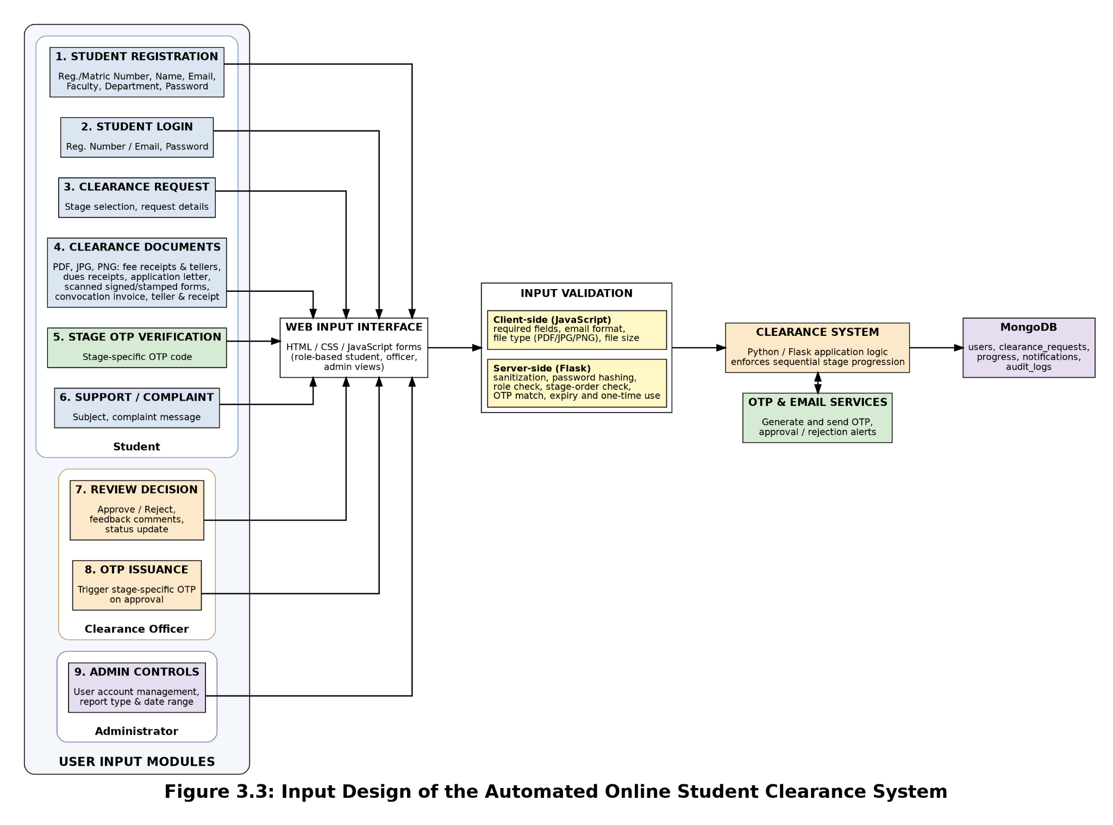

Output design defines the structured reports, notifications, clearance certificates, and dashboards generated by the system. Outputs include real-time clearance status reports, email approval/rejection alerts, OTP verification messages, administrative summary reports, and audit logs presented via intuitive web interfaces.
